# CS 255 System Design Document Template

This template lays out all the different sections that you need to complete for Project Two. Each section has guidance to prompt your thinking. You will need to continually reference the interview transcript as you work to make sure that you are addressing your client’s needs. There is no required length for the final document. Instead the goal is to complete each section based on what your client’s needs are. Remove this note when you are finished, and replace all bracketed text with the relevant information.

## UML Diagrams

### UML Use Case Diagram

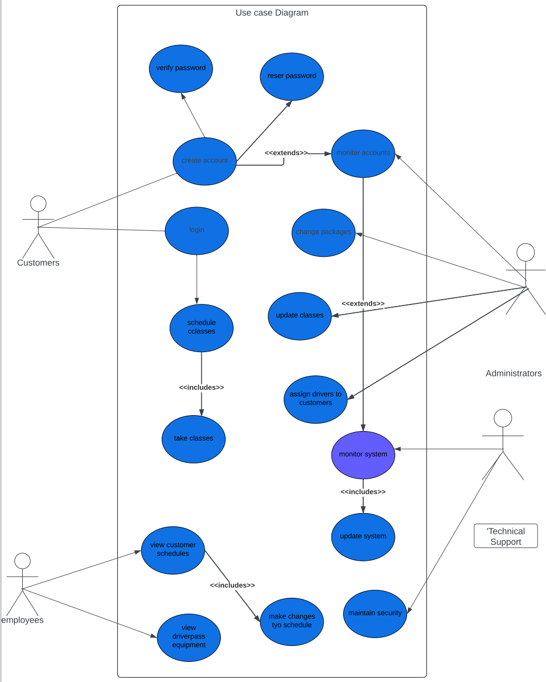

### UML Activity Diagrams

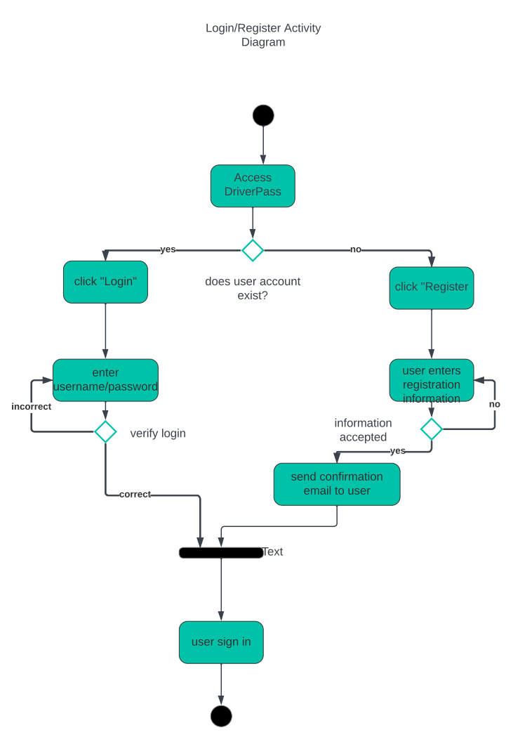

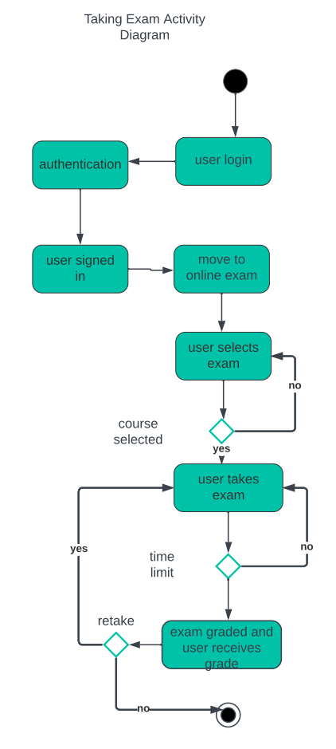

### UML Sequence Diagram

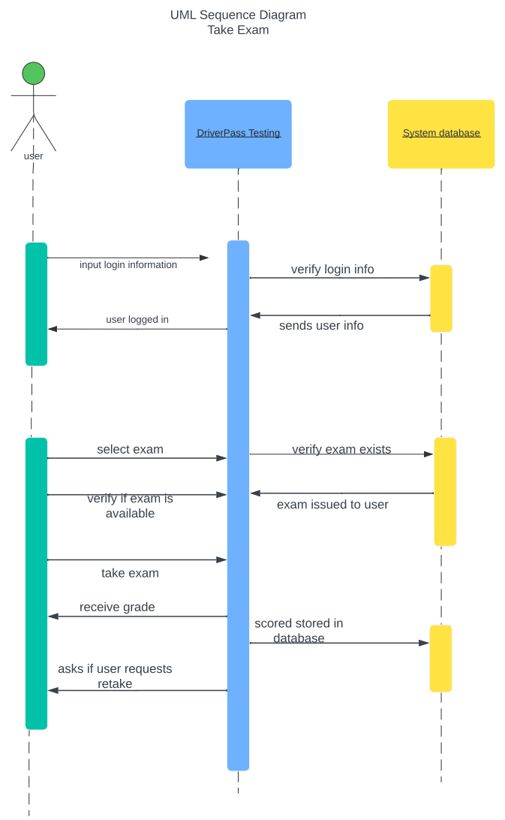

### UML Class Diagram

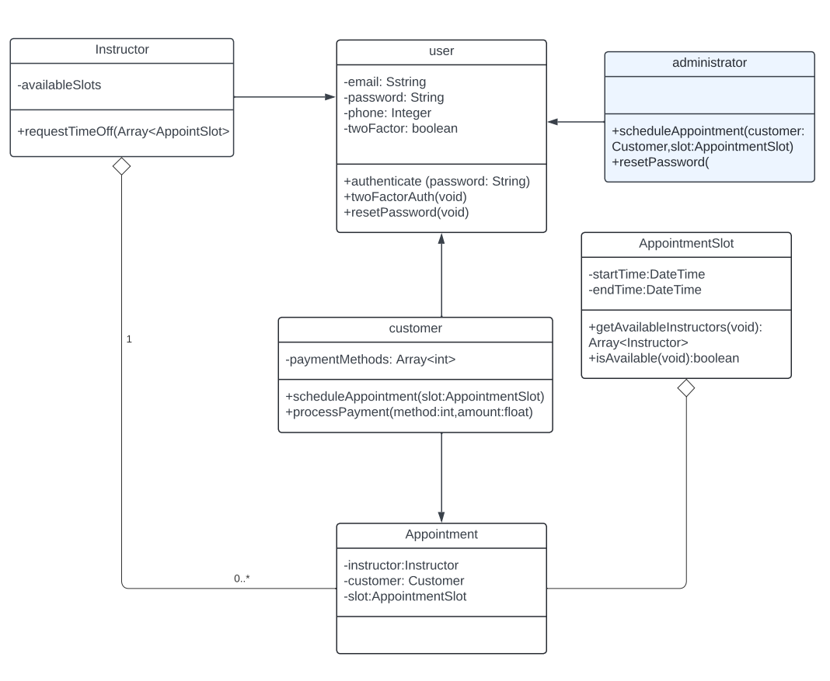

## Technical Requirements

There are several technical requirements that should be considered when designing a system. The system needs to be adequate enough to run the web interface and have enough processing power and enough storage space to run the system. Cloud based servers and networks are necessary forms of infrastructure components needed for the system to be widely available to all users. An efficient and consistent internet connection is necessary to ensure the system remains up and available at all times. The system should be integrated with external services to allow users to interact readily with the system. In order to provide the best user experience, DriverPass should consider the hardware, software, tools, and infrastructure necessary for its successful operation.